Burning The OptiBoot bootloader for the ATMega32
- Download & install the arduino software & WinAVR (if you don’t already have it)
http://arduino.cc/en/Main/Software and http://sourceforge.net/projects/winavr/files/WinAVR/20100110/

- Make a copy of the folder " \arduino-1.0\hardware\arduino\bootloaders\optiboot"
(call it optiboot32 or whatever you like – this is the folder we will work in)

- Update: Makefile, optiboot.c and pins_defs.h
- Make atmega32 (you should not get any compile errors. If so repeat steps 3 & 4)
- Build the breadboard circuit
- Borrow/buy/make an AVR programmer, connect it and test with avrdude.exe
- Read and record the original state of fuse, lock and calibration bytes. (in case you want to go back)
- Program the ATMega32 chip with the new optiboot_32_8mhz.hex file.
- Program the fuse & lock bits. (the LED attached to PB0 should now flash 4x each time the chip is reset)
- Connect your serial port adapter to TXD & RXD pins. (TTL voltages please!)
- Test with avrdude.exe (LED will flash some more…)
- Update \arduino-1.0\hardware\arduino\boards.txt
- Add the \arduino-1.0\hardware\arduino\variants\atmega32 folder with modified pins_arduino.h
- Create a simple sketch and upload it.
- Have a few beers to celebrate!!!!

Suggested breadboard schematic.
Note the optional Reset by DTE part of the circuit. Add this if your adapter supplied a DTE signal.
If your adapter can supply enough current to power the circuit, you cam omit the Power Regulator Circuit.

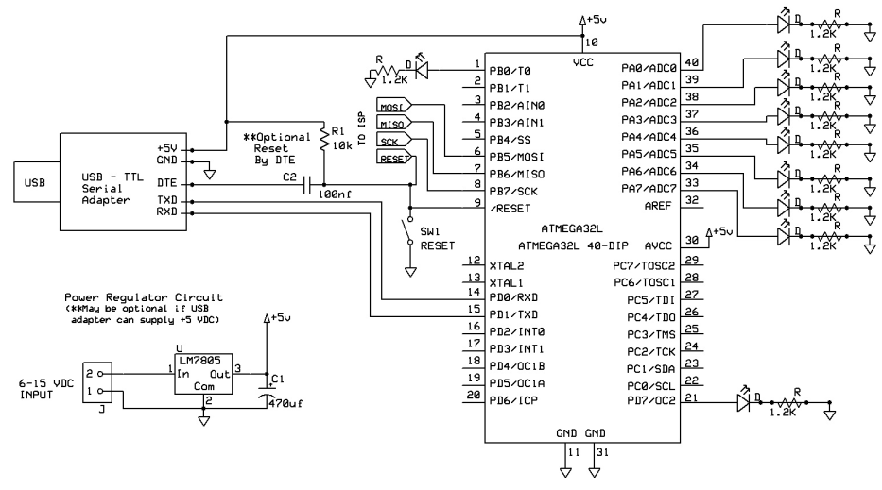
Modifications to Makefile
If you’re not interested in all the details of the changes made, skip to the page titled:
“Connecting A Programmer To the Breadboard”
Not e: Makefie is a text file with no .txt extension open it with notepad or any text editor.
If you’re not familiar with using the GCC command line tools this will seem strange.
A makefile is basically a set of rules that invoke compiler commands we will use the one provided and simply add or change some settings.
- Change the target chip. (line# 38)
MCU_TARGET = atmega32 (from MCU_TARGET = atmega168)
- Add a set of atmega32 specific build commands: (I put mine around line# 420)
atmega32: TARGET = atmega32
atmega32: MCU_TARGET = atmega32
atmega32: CFLAGS += '-DLED_START_FLASHES=4' '-DNO_SOFT_UART' '-DBAUD_RATE=19200' '-DOSCCAL_VAL=0xC3' '-DLED_DATA_FLASH'
atmega32: AVR_FREQ = 8000000L
atmega32: LDSECTIONS = -Wl,--section-start=.text=0x7E00 -Wl,--section-start=.version=0x7FFE
atmega32: $(PROGRAM)_32_8mhz.hex
atmega32: $(PROGRAM)_32_8mhz.lst
Here we (once again) set the target chip to the ATMega32 this might be redundant but let’s do it anyway
Add Compiler “-D” flags that define son constant values that will be use in the code.
LED_START_FLASHES=4 tells the code how many times the LED will flash at startup (4 is good)
NO_SOFT_UART an indicator I added to cause ship the software base UART code.
BAUD_RATE=19200 sets the bootloader baud rate. (19200 is a good choice for an 8MHZ chip)
OSCCAL_VAL=0xB4 another of my additions, sets the RC oscillator calibration value FOR MY CHIP!
YOU NEED TO DETERMINE THE VALUE FOR YOUR CHIP (OR LEAVE IT OUT)
If you do choose to set this value keep in mind the resulting bootloader code
will be specific to ONE SPECIFIC CHIP. You will need to re-compile the code
with a new value for different chips. The system loads the 1MHZ value into your
chip at startup. That’s usually very close to the 8MHZ value so omitting this
setting will not necessarily mean the code won’t work, it just makes sure it is
optimal for your chip.
LED_DATA_FLASH turns on the feature that flashed the LED while data is transmitting.
AVR_FREQ = 8000000L set the chip clock frequency for 8MHZ
LDSECTIONS these 2 commands tell the compiler that our bootloader code will be placed
in flash memory at address 0x7E00 and the version bytes will be put at
address 0x7FFE (I’ll explain how we got these values later)
$(PROGRAM)_32_8mhz.hex tell the compiler how to name our output files
$(PROGRAM)_32_8mhz.lst tell the compiler how to name our output files
That’s it for the Make file changes
We will see these again when we look at the source code changes.
Modifications to optiboot.c
- NO_SOFT UART (around line# 194)
#ifndef NO_SOFT_UART
#ifndef SOFT_UART
#define SOFT_UART
#endif
#endif
#endif
for some reason the original programmer wanted us to use a “software UART” to create the serial bits instead of the UART built into the chip hardware. (perhaps it was more reliable at really high baud rates)
I was unable to make it work on the ATMega32 with an 8MHZ RC clock, but it seemed to work fine using the hardware based UART so I added a configuration setting to override the original rule calling it “NO_SOFT_UART” (see the Makefile settings and notes in the code around line# 193)
- WATCHDOG TIMER SETTINGS (around line#210)
#if defined(__AVR_ATmega8__) || defined(__AVR_ATmega32__)
(changed from #ifndef __AVR_ATmega8__ )
The ATmega8 is quite similar in design to the ATMega32 (just a lot smaller) so many of the changethe original programmer made for that chip also apply to the ATMega32 so this change makes the exception apply to the ATMega8 OR the ATMega32 __AVR_ATmega32__ is selected by the compiler when we set the
MCU_TARGET = atmega32 in the Makefile.
- Start of RAM and Non Read-Write Start address settings. Additional lines added (around line#248)
#elif defined(__AVR_ATmega32__)
//EMK - atmega32
#define RAMSTART (0x060)
#define NRWWSTART (0x7000)
Got these values from comparing the ATMega162 and ATMega32 datasheets.
(this was a tricky one to find since with the start of ram set incorrectly the code simply didn’t work)
- Setting the OSCCAL value additional lines added (around line#292)
#ifdef OSCCAL_VAL
OSCCAL=OSCCAL_VAL; //EMK added this for atmega32 using 8mhz internal RC osc.
#endif
The original code was designed for chips using a 16MHZ crystal controlled clock source.
I wanted to use the internal RC oscillator and set it to 8MHZ. The problem here is that the RC oscillator is
not as accurate as a crystal driven oscillator, and serial communications at high baud rates demand accurate timing. To help us set the internal clock more accurately the manufacturer tests each individual chip and
stores some values on it to get the chip as close to the desired speed as it can. Four bytes are stores on the chip for 1,2,4 and 8MHZ respectively in an area called the calibration bytes (clever huh..)
YOU need to user your programmer to read these bytes and set the correct value in the Makefile.
Then the code added above will apply it to the actual OSCCAL register.
Modifications to optiboot.c (continued)

- Setting the stack pointer to RAMEND (around line# 292)
#if defined(__AVR_ATmega8__) || defined(__AVR_ATmega32__)
SP=RAMEND; // This is done by hardware reset
(changed from #ifndef __AVR_ATmega8__ )
Another bit of code specific to the ATMega8 that also needs to apply to the ATMega32
(this was another tricky one to find since with the stack pointer set incorrectly the code simply didn’t work)
- Hardware UART register and bit name differences (around line# 306)
#if defined(__AVR_ATmega8__) || defined(__AVR_ATmega32__)
(changed from #ifndef __AVR_ATmega8__ )
Another bit of code specific to the ATMega8 that also needs to apply to the ATMega32
The ATMega8 and 32 have only a single USART so the registers are named differently.
(see the code in this area for the name differences)
- LED BIT Toggle code (around line# 546, 596 and 646)
#if defined(__AVR_ATmega8__) || defined(__AVR_ATmega32__)
LED_PORT ^= _BV(LED);
(changed from #ifndef __AVR_ATmega8__ )
The ATMega8 and 32 chips need to use different code to flash the LED. The same replacement is
used in three different spots in the code (see the line# above)
- More WATCHDOG TIMER register differences - additional lines added (around line#644)
#if defined __AVR_ATmega32__
//EMK - atmega32
WDTCR |= _BV(WDTOE) | _BV(WDE);
WDTCR = x;
#else
WDTCSR = _BV(WDCE) | _BV(WDE);
WDTCSR = x;
#endif
The ATMega32 has different watchdog timer register names that the other chips supported so I added the correct replacement section above by comparing chip datasheets.

Modifications to pin_defs.h

- UART and Watchdog register names (around line#18)
#if defined(__AVR_ATmega8__) || defined(__AVR_ATmega32__)
(changed from #ifndef __AVR_ATmega8__ )
Again, there are differences in the register names between the ATmega168 and the
AtMega8 & 32 chips. Change the preprocessor rule to make the ATMega8 exceptions apply to the ATMega32 as well. Thes differences apply to the UART, TIMER1 and Watchdog Timer registers.

- LED and SOFT_UART pin & port definitions. Additional lines (around line#82)
/* EMK - ATMega32 support */
#if defined(__AVR_ATmega32__)
/* Onboard LED is connected to pin PB0 on ATMega32 */
#define LED_DDR DDRB
#define LED_PORT PORTB
#define LED_PIN PINB
#define LED PINB0
/* Ports for soft UART */
#ifdef SOFT_UART
#define UART_PORT PORTD
#define UART_PIN PIND
#define UART_DDR DDRD
#define UART_TX_BIT 1
#define UART_RX_BIT 0
#endif
#endif
Here I added a directive for specifically for the ATMega32. These tell the compiler what PORT and PIN to
use for the blinking LED. I like having the LED connected to PINB0 since it’s Pin#1 on the chip and easy to locate
on my breadboard so I added that change (other chips use PINB5 ).
There also definitions for the ports & pins to use for the software UART even though we decided not to use it.
I’m leaving these in just in case I want to try and figure out why I couldn’t make it work someday.

How to determine the fuse bit values:
Take a look at these tables on the ATMega32 datasheet. (not all on the same page )

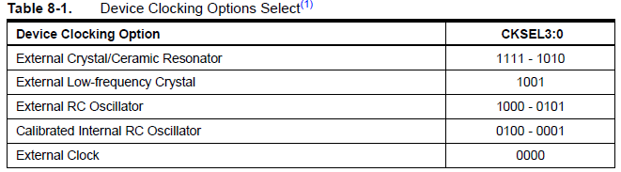

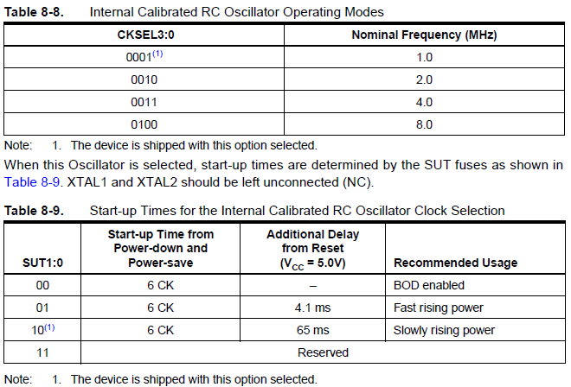

I decided I want to use the 8MHZ internal RC oscillator as my clock source, so table 8.8 says use CKSEL= 0100.
I don’t think start-up time is critical for a breadboard, but it looks like SUT=01 will start quicker so let’s use that.

CKSEL for Internal RC osc. @ 8Mhz = 0100

SUT = 01 This choice offers better performance than the default setting for slowly rising power

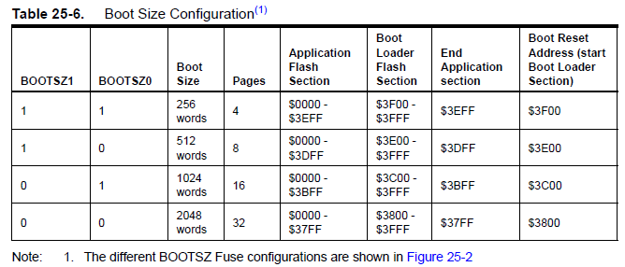

*** Sizes and address are shown in WORDS (2 bytes each)
Arduino optiboot bootloader uses approx. 512 bytes so we will use Boot Size = 256 Words (512 bytes)
with a start load/start address of $3F00 (in words) or $7E00 (in bytes)
BOOTSZ1 & BOOTSZ0 = 11
With these fuse bits set, on reset, the chip will start executing code at the bootloader address of $7E00 instead
of the default application start address of 0000. Our bootloader code will jump to address 0000 when it’s done
programming the chip or if it doesn’t get any serial data for about 2.5 seconds. (to run your application)
This is why we have the setting “--section-start=.text=0x7E00” in the Makefile. It tells the compiler to
build our code to Load & run in that address space.
I compiled the code with the Makefile & code changes described earlier and by looking at the .HEX and .LST files it
created, verified that the bootloader will fit in 512 bytes (256 words) of flash memory. This is why we can use this
BOOTSZ setting in the first place. If you added features to the bootloader code, making it larger than 512 bytes
you would simply choose the next larger block size which of course would change the start address to $3E00(in words)
or $7C00 (this also means you will have a bit less flash memory available for your programs)
The second Makefile LDSECTIONS setting is “,--section-start=.version=0x7FFE” and simply tells the compiler
where it can put our 2 byte version code. This is the last 2 bytes in out bootloader address space.

Now that we figured out some of the settings we need to have let see how to set them.
These 2 tables from the ATMega32 datasheet describe the High & Low fuse bytes and where the bits are located.
The programmed/un-programmed notations can get confusing. It simply means that flash memory that has not
yet been programmed has it’s bits set to a “1” (not “0” as one might think) We just need to be concerned with the actual bit values.
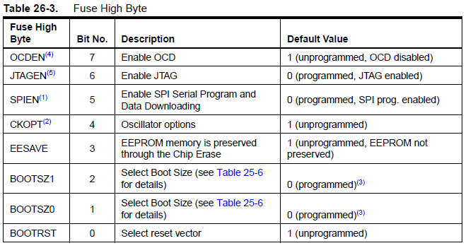
Use factory defaults for 5 other bits = 10011
BOOTSZ1 & BOOTSZ0 = 11 (bootloader size = 256 words/512 bytes – load address = $7E00)
BOOTRST = 0 (use bootloader reset address of $7E00 instead of $0000)

HFUSE=10011110 or 0x9E

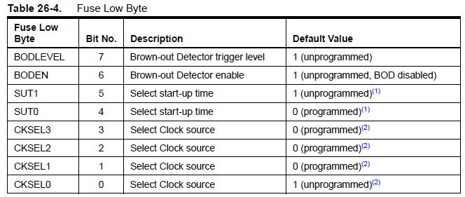
BOD bits ( use default) = 11
SUT = 01
CKSEL for Internal RC osc. @ 8Mhz = 0100
LFUSE = 11010100 or 0xD4 Great! We figured out the fuse bit values.
Connecting A Programmer To the Breadboard

IMPORTANT: Setting the fuse bits incorrectly can be a very bad thing and make your chip unusable.
For instance if you set the fuse bits to use an external crystal to control the clock and you don’t have one connected
you will have no clock source and will not be able to talk to the chip, this you will not be able to program it or correct the
bad fuse bit settings. ( until you supply the missing crystal or inject a clock signal some other way)

Having said that, let’s connect the programmer. I’m using a homemade parallel port programmer that emulates an
Atmel STK200.
Looking at the tables above we see the default values for the High fuse byte is: 10011001 or 0x99 in HEX
and the default for the Low fuse byte is: 1110001 or 0xE1.

I use avrdude.exe in terminal mode to read and set the fuse bits.
At the command prompt enter this command: avrdude -p m32 –c stk200 –t
NOTE: the “–c stk200” part of the above command is for MY programmer. Yours may be different.
See the documentation for avrdude provided with the WinAVR package.
“-p m32” tells avrdude we mean to talk to an ATMega32 chip. “–t” selects terminal mode.
If you’re really lucky and have everything connected right the first time you’ll get something like this:

avrdude: AVR device initialized and ready to accept instructions

Reading | ################################################## | 100% 0.02s

avrdude: Device signature = 0x1e9502
avrdude>

Now enter: “dump calibration”, then “dump lfuse”, then “dump hfuse” You’ll get output like this below:
avrdude> dump calibration
>>> dump calibration
0000 bb b9 b5 b4 |.... |

avrdude> dump lfuse
>>> dump lfuse
0000 e1 |. |

avrdude> dump hfuse
>>> dump hfuse
0000 99 |. |

Make a note of the calibration byte values and the original fuse byte values.
The 4th calibration value is the one for 8MHZ. (in the example above it’s “b4”)
If you choose to set it in the code modify the Makefile (e.g OSCCAL_VAL=0xB4)
Now enter Q to quit avrdude. It will respond with:
avrdude> Q
>>> Q
avrdude: safemode: Fuses OK
avrdude done. Thank you.

Building the bootloader code
Now we’re ready to build the code.
Make the change for the OSCCAL_VAL setting if you choose to do so.
Save your changes to all files.

And enter this command:
make clean

make will respond with this:
rm -rf *.o *.elf *.lst *.map *.sym *.lss *.eep *.srec *.bin *.hex

and it will have deleted all the files matching the patterns above.

Now enter:
make atmega32

You should see this:
avr-gcc -g -Wall -Os -fno-inline-small-functions -fno-split-wide-types -mshort-c
alls -mmcu=atmega32 -DF_CPU=8000000L '-DLED_START_FLASHES=4' '-DNO_SOFT_UART' '
-DBAUD_RATE=19200' '-DOSCCAL_VAL=0xB4' '-DLED_DATA_FLASH' -c -o optiboot.o opt
iboot.c
avr-gcc -g -Wall -Os -fno-inline-small-functions -fno-split-wide-types -mshort-c
alls -mmcu=atmega32 -DF_CPU=8000000L '-DLED_START_FLASHES=4' '-DNO_SOFT_UART' '
-DBAUD_RATE=19200' '-DOSCCAL_VAL=0xB4' '-DLED_DATA_FLASH' -Wl,--section-start=.t
ext=0x7E00 -Wl,--section-start=.version=0x7FFE -Wl,--relax -Wl,--gc-sections -no
startfiles -nostdlib -o optiboot_32_8mhz.elf optiboot.o
avr-size optiboot_32_8mhz.elf
text data bss dec hex filename
500 0 0 500 1f4 optiboot_32_8mhz.elf
avr-objcopy -j .text -j .data -j .version --set-section-flags .version=alloc,loa
d -O ihex optiboot_32_8mhz.elf optiboot_32_8mhz.hex
avr-objdump -h -S optiboot_32_8mhz.elf > optiboot_32_8mhz.lst
rm optiboot.o optiboot_32_8mhz.elf

This shows the output messages from the compile process.
You should see no message with “error” or “warning” if so, something is wrong check the instructions carefully. If necessary re-load all the original files and start again.

Once successful you should have the following 2 new files
optiboot_32_8mhz.hex and optiboot_32_8mhz.lst

The .hex file is what we will load onto the chip.
The .lst file is a text file that shows the source line and the assembly they produced.
(Interesting reading )

Let’s move on the programming the chip.

Uploading the bootloader code to the Atmega32 chip

Back to avrdude.
Enter this command: avrdude –p m32 –c stk200 –U flash:w:optiboot_32_8mhz.hex
REMEMBER: stk200 is the command for MY PROGRAMMER yours may be different.

Here’s what you will get:
avrdude: AVR device initialized and ready to accept instructions

Reading | ################################################## | 100% 0.02s

avrdude: Device signature = 0x1e9502
avrdude: NOTE: FLASH memory has been specified, an erase cycle will be performed

To disable this feature, specify the -D option.
avrdude: erasing chip
avrdude: reading input file "optiboot_32_8mhz.hex"
avrdude: input file optiboot_32_8mhz.hex auto detected as Intel Hex
avrdude: writing flash (32768 bytes):

Writing | ################################################## | 100% 11.56s

avrdude: 32768 bytes of flash written
avrdude: verifying flash memory against optiboot_32_8mhz.hex:
avrdude: load data flash data from input file optiboot_32_8mhz.hex:
avrdude: input file optiboot_32_8mhz.hex auto detected as Intel Hex
avrdude: input file optiboot_32_8mhz.hex contains 32768 bytes
avrdude: reading on-chip flash data:

Reading | ################################################## | 100% 10.36s

avrdude: verifying ...
avrdude: 32768 bytes of flash verified

avrdude: safemode: Fuses OK

avrdude done. Thank you.

If you were watching your breadboard just as avrdude finished you would have noticed The LED blinking 4 times. (Probably very slowly since the chip is still running at the 1 MHz default speed)
Reset the chip to see it again…

Finally lets properly set the fuse bits.
Again let’s start avrdude in terminal mode with this command:
avrdude -p m32 -c stk200 -t

Now enter this: write lfuse 0000 0xd4
avrdude will respond with:
>>> write lfuse 0000 0xd4

Then enter this: write hfuse 0000 0x9e
avrdude will respond with:
>>> write hfuse 0000 0x9e

Finally this: write lock 0000 0x0f
avrdude will respond with:
>>> write lock 0000 0x0f

Now enter: dump hfuse then dump lfuse again to verify we made the change
You’ll get output like below:
avrdude> dump hfuse
>>> dump hfuse
0000 9e

avrdude> dump lfuse
>>> dump lfuse
0000 d4

Now enter Q to quit avrdude.

Disconnect your programmer and connect your TTL serial adapter.

Pin 14 is RXD (data from the ATMega32) and Pin 15 id TXD (data TO the chip)
Connect your adapter accordingly - Adapter RXD -> chip TXD and adapter TXD - > chip RXD.

If you don’t know what COM port it’s configured for use the Windows Device Manager tool to
display the available COM ports.

Now type in this command(DO NOT PRESS ENTER YET):
avrdude -p m32 -c arduino -P COM1 -b 19200

Hold down the reset switch on your breadboard and release it just as you press Enter.
(If you have the DTR signal connected to RESET as described in the schematic you don’t need to hold RESET.
DTR will reset the chip for you at the right time)
avrdude will hopefully respond with:
avrdude: AVR device initialized and ready to accept instructions

Reading | ################################################## | 100% 0.02s
avrdude: Device signature = 0x1e9502
avrdude: safemode: Fuses OK
avrdude done. Thank you.

Uploading Your First Program with the Bootloader

In the download package I’ve included a pre-built test program and re-named the .hex
file to .bin so the make – clean process doesn’t delete it.

Now type in this command(DO NOT PRESS ENTER YET):
avrdude -p m32 -c arduino -P COM1 -b 19200 -U flash:w:uart_pa1.bin

Same as before you may have to hold the RESET as you enter the command.
You’ll see something like this:
avrdude: AVR device initialized and ready to accept instructions

Reading | ################################################## | 100% 0.02s

avrdude: Device signature = 0x1e9502
avrdude: NOTE: FLASH memory has been specified, an erase cycle will be performed
To disable this feature, specify the -D option.
avrdude: erasing chip
avrdude: reading input file "uart_pa1.bin"
avrdude: input file uart_pa1.bin auto detected as Intel Hex
avrdude: writing flash (4964 bytes):
Writing | ################################################## | 100% 3.32s

avrdude: 4964 bytes of flash written
avrdude: verifying flash memory against uart_pa1.bin:
avrdude: load data flash data from input file uart_pa1.bin:
avrdude: input file uart_pa1.bin auto detected as Intel Hex
avrdude: input file uart_pa1.bin contains 4964 bytes
avrdude: reading on-chip flash data:
Reading | ################################################## | 100% 3.14s
avrdude: verifying ...
avrdude: 4964 bytes of flash verified
avrdude: safemode: Fuses OK
avrdude done. Thank you.

Now the LEDs on PORTA should start blinking and if you run a terminal program (like HyperTerm) and attach it
to your serial port you will see a menu appear. (you may have to reset the chip again to see this)

avrdude -p m32 -c arduino -P {my COM port} -b 19200 -U flash:w:{my_filname.hex}

Now using the above command with your bootloade enabled ATMega32 chip you can
upload code to the chip using your serial port connection – no programmer needed.
This make like simpler in a couple of ways.
- You don’t have to carry around both a programmer and a serial device.
- Since the serial device is a handy debugging tool it’s already connected and
ready for use with all your programs.
Additionally; with a few minor configuration changes, you can upload and run Arduino
sketches on your new setup.

Setting the Arduino 1.0 Environment for the ATMega32

If you downloaded and installed the Arduino 1.0 software package you can make a few changes and use it with
the ATMega32 bootloader enabled chip.

In the folder " \arduino-1.0\hardware\arduino\cores\arduino" ther is a boatds.txt file.
Add these lines of text to that file.
##############################################################
atmega32.name=ATMega32
atmega32.upload.protocol=arduino
atmega32.upload.maximum_size=32256
atmega32.upload.speed=19200
atmega32.bootloader.low_fuses=0x9e
atmega32.bootloader.high_fuses=0xd4
atmega32.bootloader.path=optiboot
atmega32.bootloader.file=optiboot_32_8mhz.hex
atmega32.bootloader.unlock_bits=0x3F
atmega32.bootloader.lock_bits=0x0F
atmega32.build.mcu=atmega32
atmega32.build.f_cpu=8000000L
atmega32.build.core=arduino
atmega32.build.variant=atmega32
##############################################################
In the .zip file I provided you’ll find a copy of pins_arduino.h that’s modified
for the ATMega32.

In the arduino install location there’s this folder:
"\arduino-1.0\hardware\arduino\variants"
Within that folder are several other folders to support other boards.
Add a folder called “ATMega32” and within that folder place the copy of
pins_arduino.h that I modified (from the .zip file I supplied)

Inside pins_arduino.h there an important comment/diagram:

// ATMEL ATMEGA32 / ARDUINO
// +---\/---+
// (D 8) PB0 1| |40 PA0 (AI 0 / D24)
// (D 9) PB1 2| |39 PA1 (AI 1 / D25)
// INT2 (D10) PB2 3| |38 PA2 (AI 2 / D26)
// PWM (D11) PB3 4| |37 PA3 (AI 3 / D27)
// SS (D12) PB4 5| |36 PA4 (AI 4 / D28)
// MOSI (D13) PB5 6| |35 PA5 (AI 5 / D29)
// MISO (D14) PB6 7| |34 PA6 (AI 6 / D30)
// SCK (D15) PB7 8| |33 PA7 (AI 7 / D31)
// RST 9| |32 AREF
// VCC 10| |31 GND
// GND 11| |30 AVCC
// XTAL2 12| |29 PC7 (D 23)
// XTAL1 13| |28 PC6 (D 22)
// RX (D 0 )PD0 14| |27 PC5 (D 21) TDI
// TX (D 1) PD1 15| |26 PC4 (D 20) TDO
// INT0 (D 2) PD2 16| |25 PC3 (D 19) TMS
// INT1 (D 3) PD3 17| |24 PC2 (D 18) TCK
// PWM (D 4) PD4 18| |23 PC1 (D 17) SDA
// PWM (D 5) PD5 19| |22 PC0 (D 16) SCL
// PWM (D 6) PD6 20| |21 PD7 (D 7) PWM
// +--------+

The Arduino system maps each I/O pin on the chips it supports to a digital pin# or optionally also an analog pin#.
The diagram above shows the chip pins, the ATMega32 function, and the arduino pin numbers.

For example arduino digital pin#8 maps to PORTB–BIT0 (PB0) on the ATMega32 (pin 1 on the chip).
Since PORTA pins also support the A/D inputs PA0-PA7 are mapped to pins AI0-AI7 in the
arduino system the same pins are also mapped as digital pins 24-31 (D24 – D31).

Some digital pins can be used for PWM output by the arduino they are marked with PWM above.

The arduino actually uses a custom version of avrdude to upload shetches.
It builds the command line from the information we placed in boards.txt
Now we’re ready to test an Arduino sketch.
Using the Arduino 1.0 IDE with the ATMega32 breadborad.

Let’s try the Arduino Blink example.
Start the Arduino 1.0 IDE and selest File –> Examples –> 1. Basic –> Blink.
That example flashes digital pin# 13 on the arduino boards. On the ATMega32 it’s mapped to
PB5 (pin#6 on the ATMega32). Connect an LED to that pin.

When you select Tools -> Board there should be a new entry in the list called “AtMega32”
Select that board.
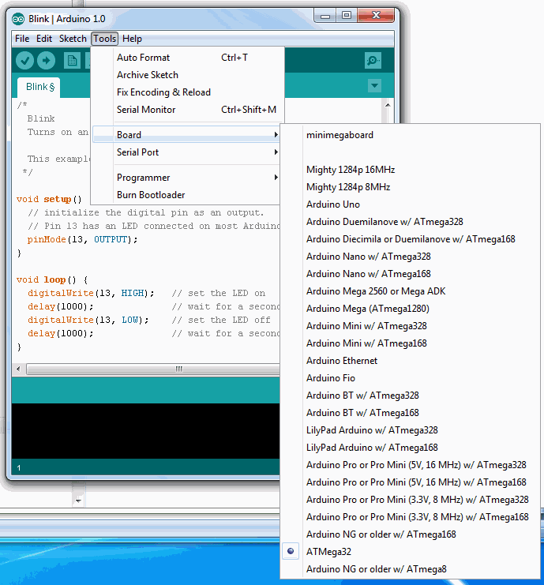

Then select Tools - > Serial Port and select the COM port your breadboard will use.

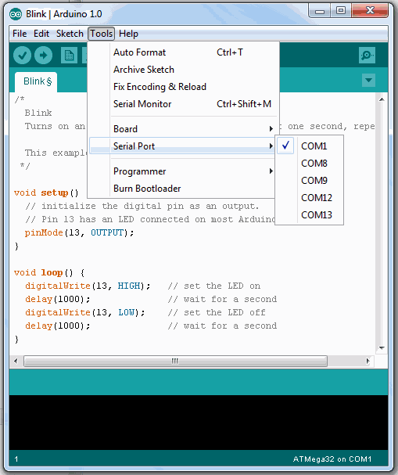

Now click on the “Upload” button (right pointing arrow on toolbar).
The status bar will say “Compiling Sketch” (hold down the reset key on you board)
After a few seconds the statu will change to “Uploading… ” (release the reset button as soon as you see this)
After a couple of seconds the status will change to “Done Uploading.”
The LED attached to Pin#6 on your chip will start top blink about once per second.

Try the “Fade” example sketch. This one uses PWM mode on Arduino digital pin 9.
The ATMega32 mappings don’t support PWM on pin 9 so you will need to modify the sketch to use pin 7 instead.
Digital pin 7 maps to PD7 on the ATMega32 and that’s connected to pin 21 on the chip.
Connect your LED to pin 21 on the ATMega32, change 2 references from pin 9 to pin 7 in the sketch, and
upload using the same procedure as before. (The IDE should remember the last Board and Port selection you used)
The LED on pin 21 of the chip should be slowly getting bright then dim.

